**System Requirements Specification**

**Machine Learning Algorithm for Rhinoplasty (M-LAR)**

**SE 450, Fall, 2020**

Team Name: Nose Surgery 1

Team Members:

* Chris Graziano
* Victoria Jordan
* Anton Kiselev
* Jacob Preseau
* Chintan Thakrar

Contents of this Document

Introduction

* System to be Produced
* Applicable Standards

Definition, Acronyms, and Abbreviations

Product Overview

* Assumptions
* Stakeholders
* Event Table
* Use Case Diagram
* Use Case Descriptions

Specific Requirements

* Functional Requirements
* Interface Requirements
* Physical Environment Requirements
* Users and Human Factors Requirements
* Documentation Requirements
* Data Requirements
* Resource Requirements
* Security Requirements
* Quality Assurance Requirements

Supporting Material

**Section 1: Introduction**

**System to be Produced** - Written by Victoria Jordan

* The system will provide a patient with representative similar faces with different nose types that align with the measurements of their face, therefore allowing the patient to select which nose is preferred for their rhinoplasty procedure.

**Applicable Standards** - Written by Chris Graziano

* The program will adhere to all HHS regulations on medical standards.

**Definitions, Acronyms, and Abbreviations** - Written by Chris Graziano and Jacob Preseau

* "Patient" and "User" are used as interchangeable terms.
* KNN - "*k*-nearest neighbors", a machine learning algorithm that, when given a test point represented by a point on the coordinate plane, will find the *k* points in the data set, also in the coordinate plane, that are nearest to the test point.

**Section 2: Product Overview**

**Assumptions** - Written by Jacob Preseau

* The product will be delivered through a standalone Python application.

**Stakeholders** - Written by Jacob Preseau

* User - The user's interest is in being able to use the product to select their preferred nose for their procedure.
* Doctor - The doctor performing the user's rhinoplasty procedure would benefit from knowing exactly what changes are needed to perform the procedure.

**Event Table**

|  |  |  |  |
| --- | --- | --- | --- |
| Event Name | External Stimuli | External Responses | Internal data and state |
| Doctor scans patient face | Doctor | None | App transform photo into coordinate file |
| Bad photo | None | None | App notifies that photo is not appropriate |

**Use Case Model** - Written by Anton Kiselev

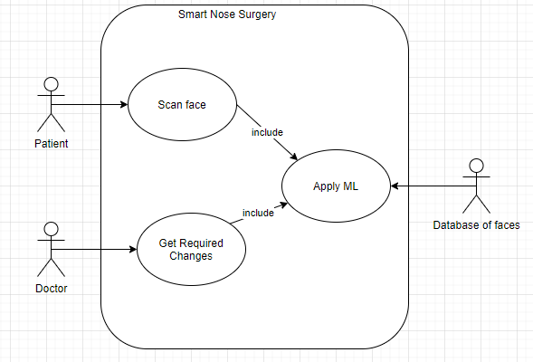

**Use Case Descriptions** - Written by Anton Kiselev

* **Scan face** - System asks the patient to provide an image of their face. The patient uploads an image of their face to the system.
* **Apply ML** - Included use case. The system gets images from the database to apply the KNN algorithm.
* **Get Required Changes** - Use case includes “Apply ML” use case. After applying KNN and getting the closest faces, the doctor receives required changes on the patient face from the system.

**DFD Models** - Written by Anton Kiselev

DFD Model level 0

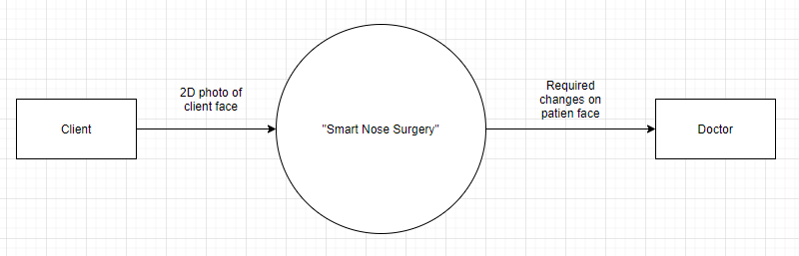

DFD Model level 1

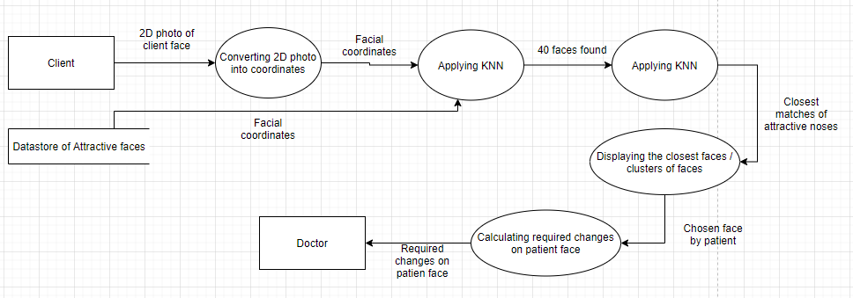

DFD Model level 1 extended state Applying KNN

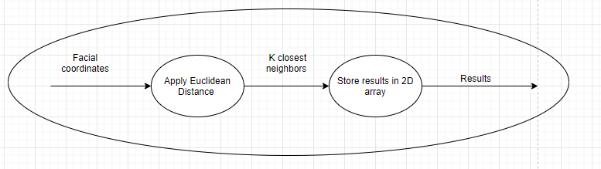

**DFD Description** - Written by Anton Kiselev

* DFD model level 0 - in this model, we can see three main components: a source of data - Client, main process - “Smart Nose Surgery” and sink for data - doctor.
* DFD model level 1 - in this model we expanded the main process into several smaller processes to get a better idea of what is behind it. First of all the system converts a patient photo into a facial coordinates and retrieves facial coordinates of different people from the data store. After that, the process “Applying KNN” which is described below level 1 model, will do calculations. In the extended state, the model shows that the algorithm, apply Euclidean distance check and store results for future access. After applying KNN for faces, the next process will display the results of KNN with noses and let the client choose the desired face. The last process will calculate the required changes for the client's face and doctor will get the data of it.

**State Chart Model** - Written by Anton Kiselev

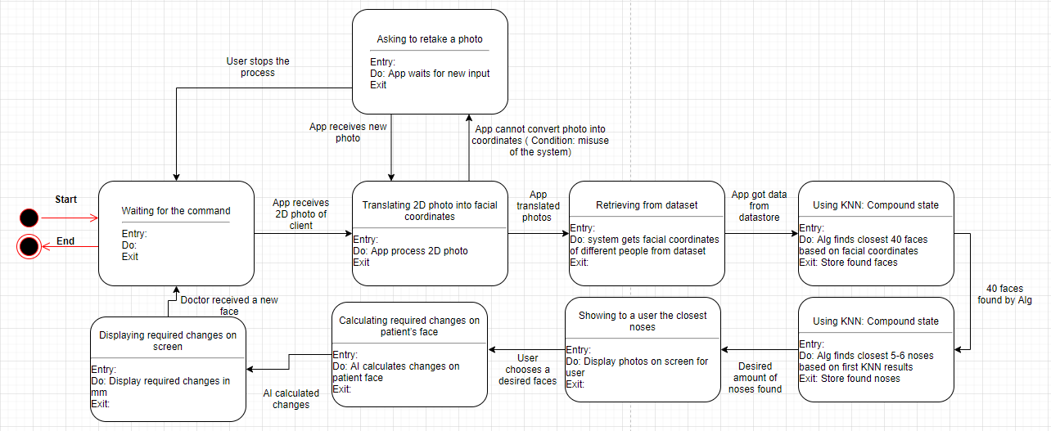

**State Chart Description** - Written by Anton Kiselev

* State Chart allows seeing what states and conditions will be in the system. This state chart represents the basic cycle of the process.
  + The system waits for the command.
  + After receiving photos, the system will transform it into a file with facial coordinates.
    - Possible error: photo taken incorrectly, system will ask a user to retake photo.
    - User may cancel the process and system will get into initial state
  + After a successful transformation, the system will be obtaining files from the datastore.
  + After that, the system will apply KNN to find 40 closest faces.
  + After that, the system will apply KNN to find 5-6 closest noses.
  + The system will display the result for a user and allow him to choose the desired faces.
  + After the client chooses the desired face, the system will be calculating the required changes and display them to the doctor.
  + After that doctor receives the final results and the system will be ready for a new cycle.

**Section 3: Specific Requirements**

|  |
| --- |
| No: <unique requirement number> |
| Statement: <the "shall" statement of the requirement> |
| Source: <source of the requirement> |
| Dependency: <list each other requirement on which satisfaction of this requirement depends. (May be "None")> |
| Conflicts: <list each other requirements with which this requirement conflicts. (May be "None")> |
| Supporting Materials: <list any supporting diagrams, lists, memos, etc.> |
| Evaluation Method: <How can you tell if the completed system satisfies this requirement? > |
| Revision History: <who, when, what> |

3.1 Functional Requirements - Written by Anton Kiselev

1. System shall allow a user to scan their face with a camera.
2. System shall be able to transform the picture of the user's face into a set of coordinates representing facial landmark measurements.
3. The coordinate files will contain an array of 67 variables that can be used to uniquely characterize each face in the database and that of the user.
4. System shall ask a user to retake the photo in case coordinate detection fails.
5. System shall be able to get the files representing faces from the database.
6. System shall be able to apply the KNN algorithm on the files in the database.
   1. System shall be able to apply KNN with the user's face as the test point, using all landmarks other than those relating to the nose.
   2. System shall be able to save the closest 40 faces from the dataset into an array.
   3. System shall be able to apply KNN on 40 faces and the user’s face, using only the landmarks relating to the nose.
   4. System shall save the 5 closest faces into an array.
7. System shall be able to display faces stored in the array.
8. The user shall be presented 5 different noses.
9. System shall allow the user to choose a nose from the 5 presented.
10. System shall be able to calculate required changes on the user’s face.
    1. System shall be able to calculate distances between the nose points of the user face and the chosen face.
    2. System shall be able to display changes on the user’s photo.
    3. System shall be able to save the photo with final changes.
11. System shall allow the doctor to access the final photo with text explaining changes to be made.

3.2 Interface Requirements - Partially written by Anton Kiselev(1-5)

1. Photo is an input for that app
2. System shall receive one user’s face at a time

3.3 Physical Environment Requirements (Victoria)

1. The system shall operate on any computer operating system (i.e. Linux, Windows) that supports Python 3.

3.4 User and Human Factors Requirements - Written by Anton Kiselev

1. The users of the system shall be the patients and the doctor.
2. The system shall provide instructions for use.
3. For each user shall be provided a brief description of the output.
4. No users require any special accommodations.
5. System shall be able to prompt the user to retake their photo in case of coordinate detection failure.

3.5 Documentation Requirements (Chintan Thakrar)

1. All shareholders will be provided with a user manual.
2. The user manual shall specifically describe how to use the system.
3. The user manual shall specifically describe the purpose of the system.

3.6 Data Requirements: Chris

1. The initial 40 faces will be selected with the KNN machine learning algorithm, using Euclidean distance as the distance metric.
2. The final 5 noses will be selected with the KNN machine learning algorithm, using Euclidean distance as the distance metric.
3. The precision of the algorithm, represented by user approval rating, shall be at least 80%
4. The only data that will be obtained from trials is whether or not the user successfully found a nose they approved of.
5. The face library will exist as a part of the app, and not on a network.

3.7 Resource Requirements: Chris

1. The system requires a skilled team to build.
2. The system will be operable by anyone familiar with a computer.
3. The system will require minimal resources upon launch.
   1. There will be no skilled personnel required to maintain the system.
   2. The system will run on, and be managed during operation, by the user’s machine.
   3. The system is scheduled to be ready on December 1st, 2020.
   4. No additional funding is required.
   5. No additional hardware is required.
   6. Software tools used include: GitHub, ZenHub, Anaconda 3 (and all of its included tools), as well as the cv2 and dlib Python libraries.

3.8 Security Requirements (Victoria)

1. The system shall verify login credentials through the API associated with the user.
2. The system shall lock users out for 1 minute if the verification process fails 3 times consecutively.

**Section 4: Changelog**

|  |  |  |
| --- | --- | --- |
| **Date/Time** | **Author** | **Description** |
| September 17, 3:24 PM | Jacob Preseau | Added Team Name and Team Members |
| September 18, 11:47 PM | Chris Graziano | Added Project Name and Course, Semester, Year; first bullet in Definitions |
| September 18, 11:47 PM | Victoria Jordan | Added System to be Produced |
| September 21, 3:15 PM | Jacob Preseau | Added Assumptions, first bullet in Stakeholders, and second bullet in Definitions |
| September 21, 5:55 PM | Anton Kiselev | Added Use Case Model, DFD Models, and State Chart Model |
| September 21, 7:05 PM | Jacob Preseau | Added second bullet in Stakeholders, Use Case Descriptions |
| September 22, 3:31 PM | Chris Graziano | Added Applicable Standards |
| September 23, 5:44 PM | Anton Kiselev | Updated Use Case Model, model descriptions |
| September 24 | Chris Graziano, Victoria Jordan, Anton Kiselev, Chintan Thakrar | Added Requirements |
| September 25 | Chris Graziano, Victoria Jordan, Anton Kiselev, Jacob Preseau, Chintan Thakrar | Revised Requirements |
| September 25 | Anton Kiselev | Updated models and description |